Aws Load balancer:

Step 1: We launch the two instances with two different availability zones

Step2: We select the Load balancer type (I select the application load balancer) and click on create.

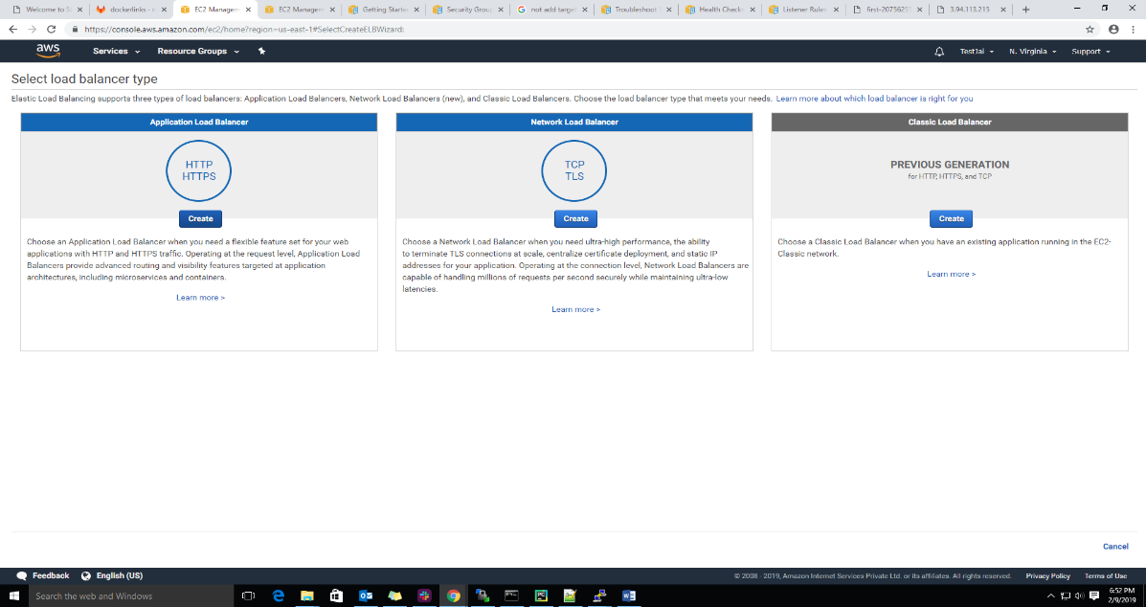

Step 3: Now, we configure the load balancer, give the load balancer name.

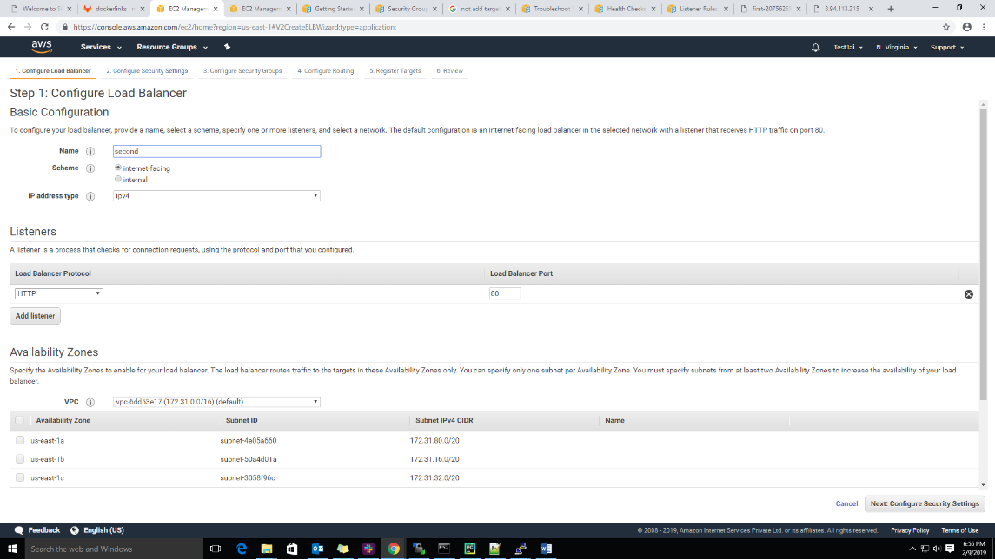

Step 4: Now, we select the scheme (internal or internet-facing) and select the IP address type.

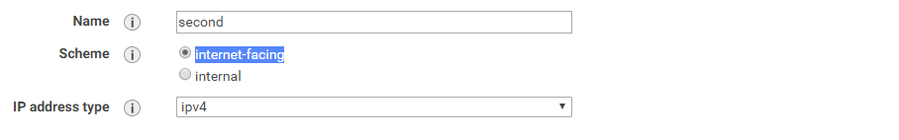

Step 5: Now, we can choose the listeners (means http or https), ports

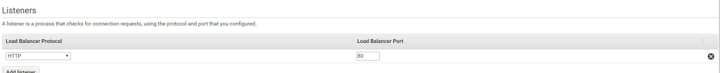

Step 6: Now, we can create the security group for load-balancer (here we create or select existing group enable port at inbound rule)

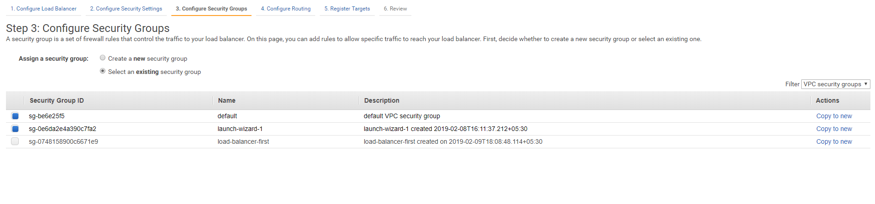

Step 7: Now we configure the load routing , click on next register Targets

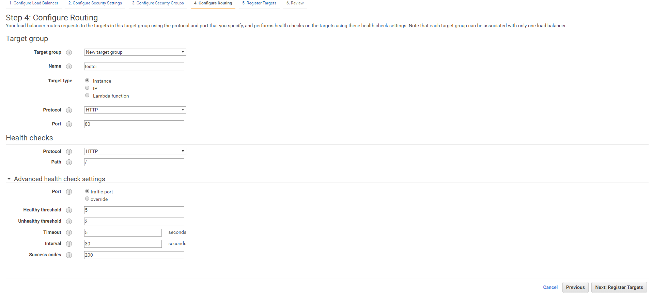

Stp 8: now we need to add(registered) instances to load-balancer taget group, after add click on review.

Before instance add:

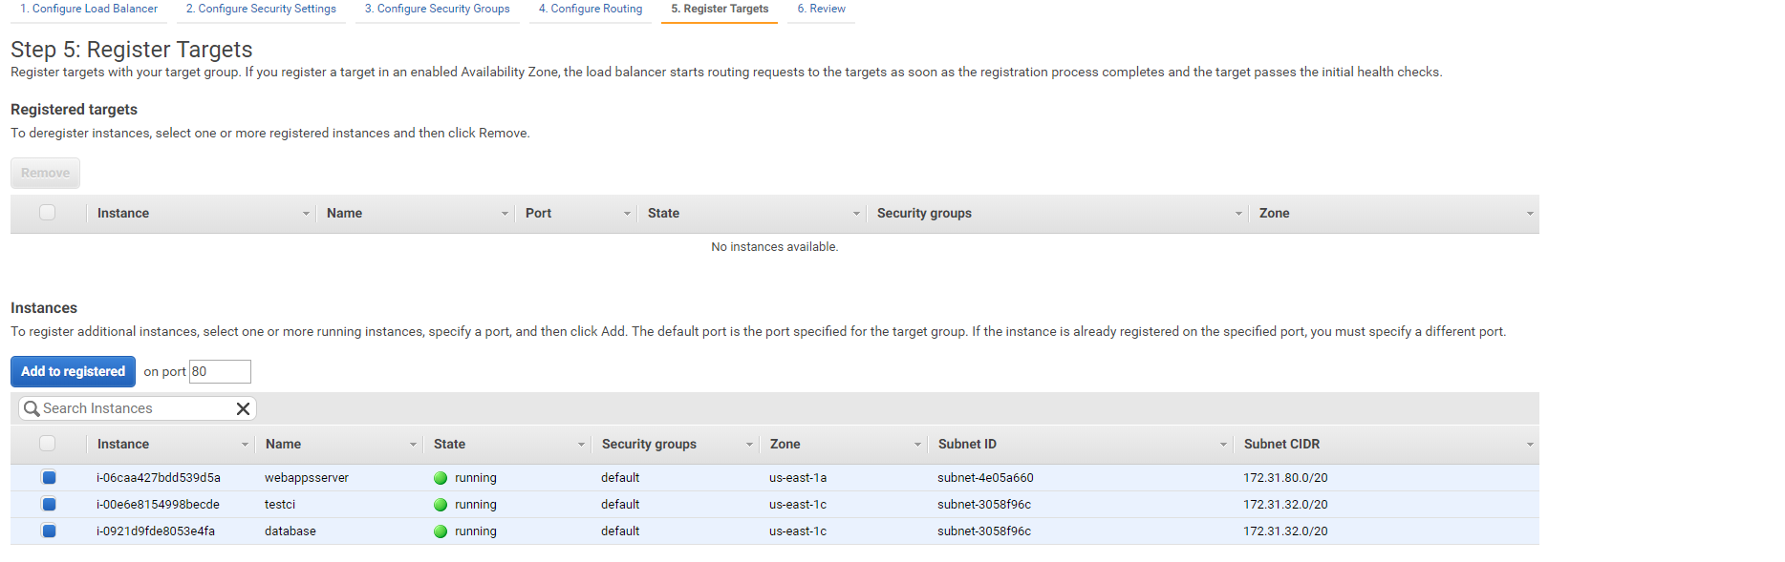

Afeter instance add:

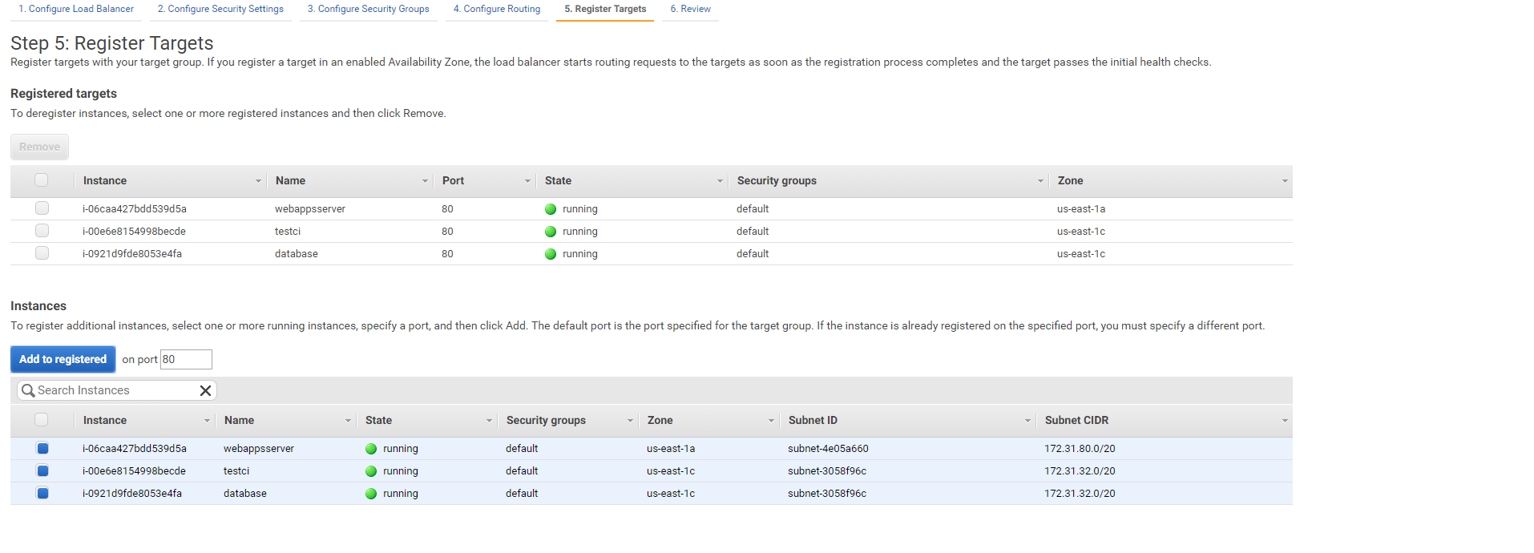

After launch load-balancer dash board

